DANNY DINER CASE STUDY

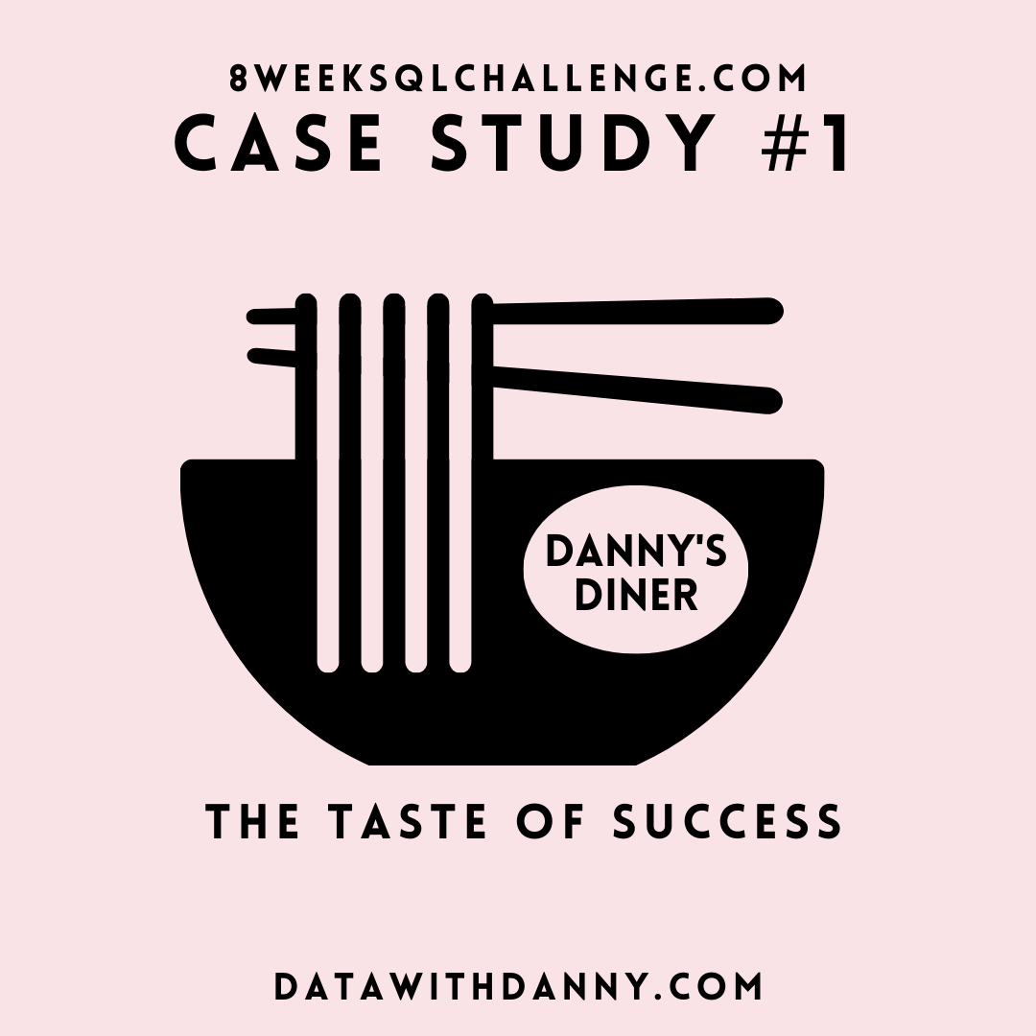

We have **3** key datasets for this case study:

* **Sales**
* **Menu**
* **Members**
* The sales table captures all customer_id level purchases with an corresponding order_date and product_id   information for when and what menu items were ordered. Below is the snapshot from sales table.

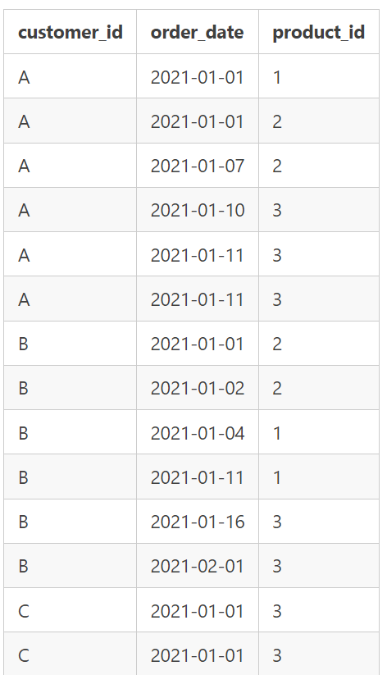

* The menu table maps the product_id to the actual product_name and price of each menu item. Below is the snapshot from menu table.

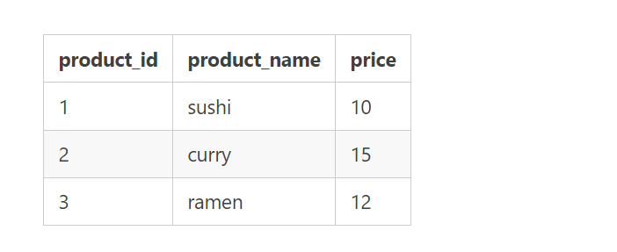

* The final members table captures the join_date when a customer_id joined the restaurant.

Below is the snapshot from members table.

